NAME: _____________________________________
Asia Study Guide
Test Friday, March 4th
Vocabulary:
- constitutional monarchy- government headed by a prime minister and a constitution with a king or queen for ceremonies (citizens have many rights and high civic participation)
- monarchy- government headed by a king or queen
(citizens have fewer rights than a democracy or constitutional monarchy and low civic participation)
- democracy- government where power is held by the people who vote for representatives to represent them in government (citizens have many rights and high civic participation)
- dictatorship- government run by a strict dictator who seizes power (citizens have few rights and low civic participation)
- urbanization- people moving from the countryside to the city for jobs
- urban = city
- rural = country
- market economy (aka capitalism)- private citizens can own big businesses, citizens make all business decisions, supply and demand determine price
- command economy (aka communism)- government controls business, production, supply and price; government makes major economic decisions
- mixed market economy (aka socialism)- government controls big business, citizens can own small businesses

Urbanization:
- Define “Urbanization”. ___________________________________________________________________________________
- Main Reason urbanization is happening in Asia: _______________________________________________________________
- A ____________ factor makes you want to move.
- A_______________ factor is what draws you into a new place.

Examples of Push Factors | Examples of Pull Factors

Map: Please label the countries on the map below.

- China B. India C. North Korea D. Japan E. South Korea
F. Bangladesh G. Thailand H. Phillipines
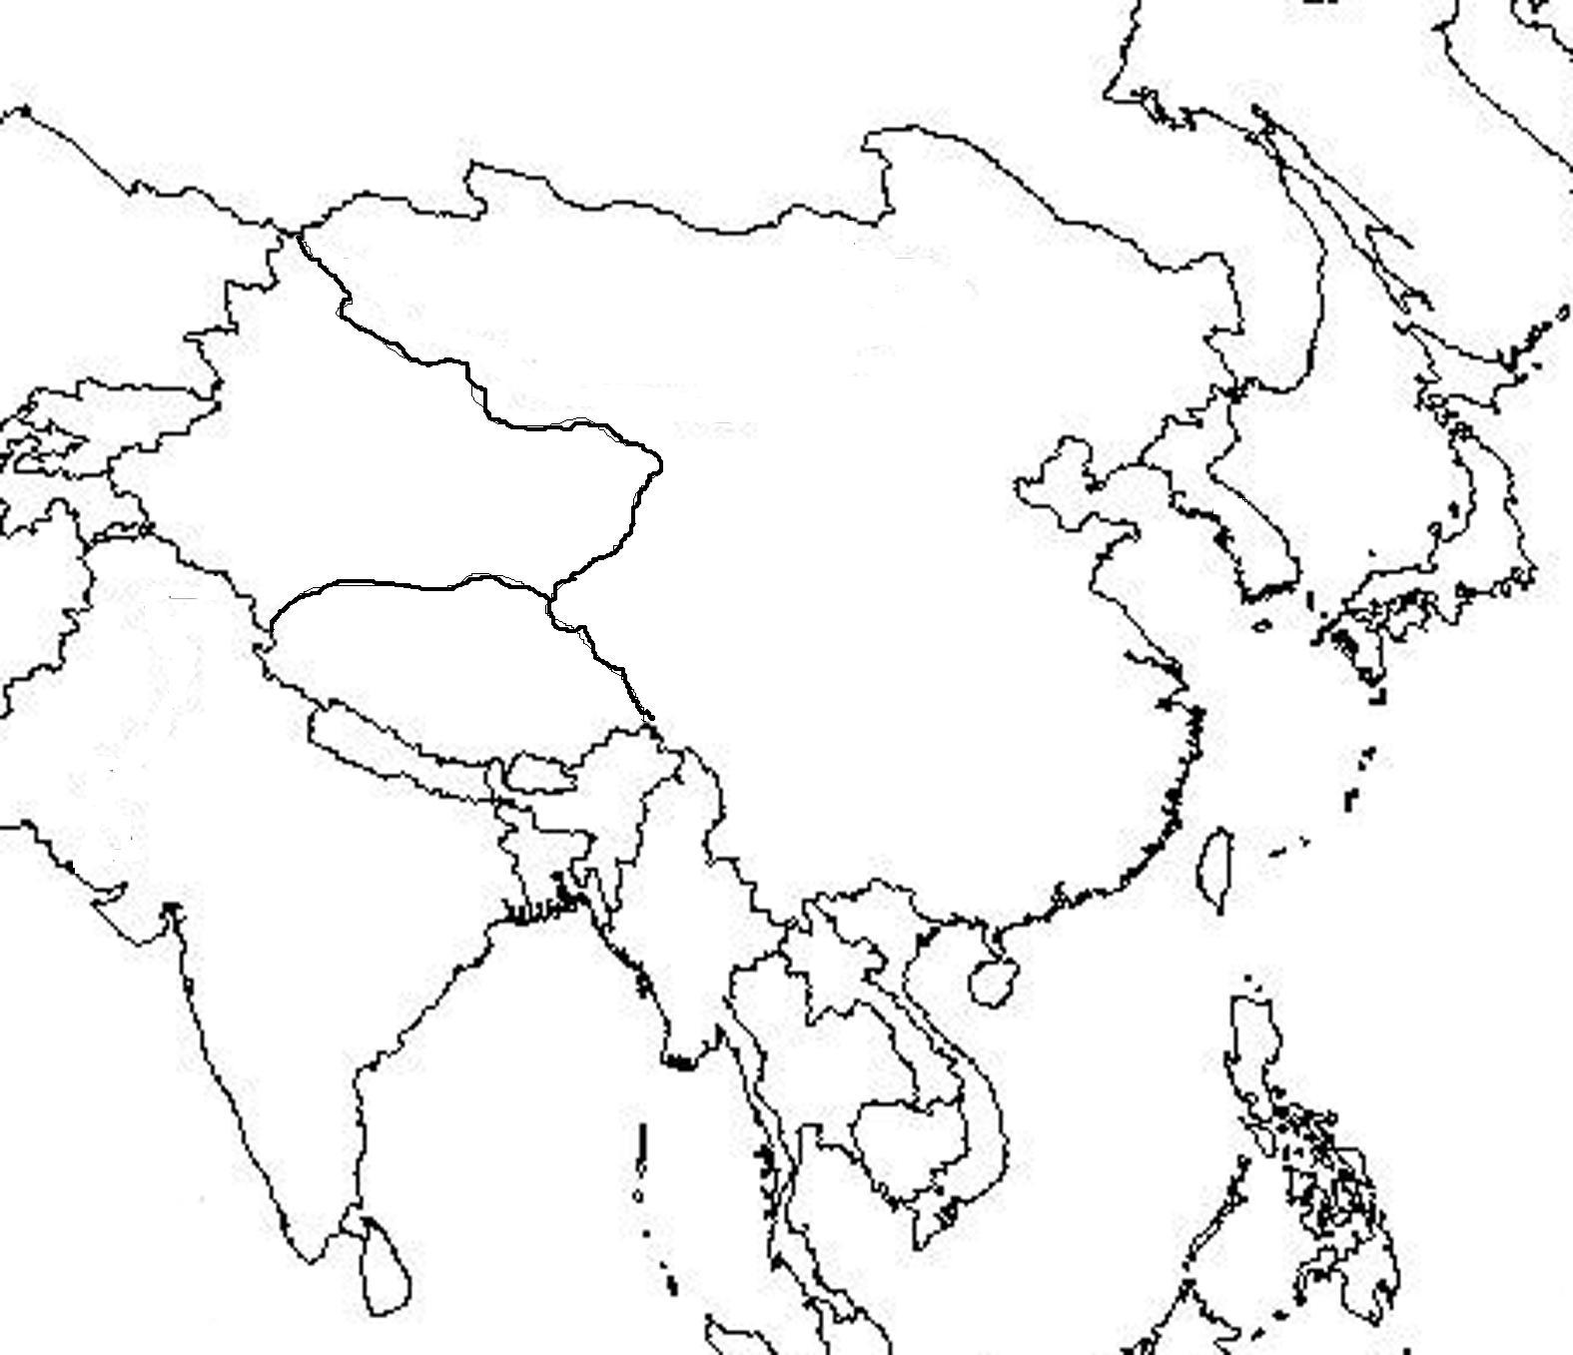

Types of Governments:

 | Democracy | Constitutional  Monarchy | Dictatorship | Monarchy | Communism
Citizen Rights  (write high or low) |  |  |  |  | LOW  Strict government limits rights
Civic Participation  (write high or low) |  |  |  |  | LOW  citizens can only vote for communist party
Leader is called... |  |  |  |  | COMMUNIST PARTY  1 party who elects a leader of that party
Which countries have we studied in Asia? |  |  |  |  | CHINA
Summarize what life is like in this type of government. |  |  |  |  | - limited freedom  - cannot speak out or go against government  - only one political party that makes all political and economic decisions

TYPES OF ECONOMIES:

 | Capitalism | Socialism | Communism
Another Name =
Who makes business decisions?
Who controls production?
(what to make and how to make it)
Who controls distribution? (how much of supplies or wealth people get)
Who controls big business?
(i.e. steel making, construction, transportation)
Who controls smaller/ private business?
(i.e. stores, restaurants etc.)
Advantages:
Disadvantages:
Examples:

